EXPRIMENT NO:4
EXPERIMENT NAME: INFORMATION GATHERING USING THEHARVESTER
Procedure:
STEP 1: Open Terminal in the kali Linux

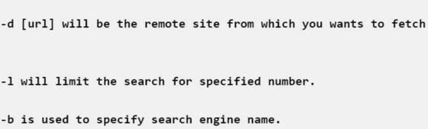

STEP 2: Run the following command
OUTPUT:

